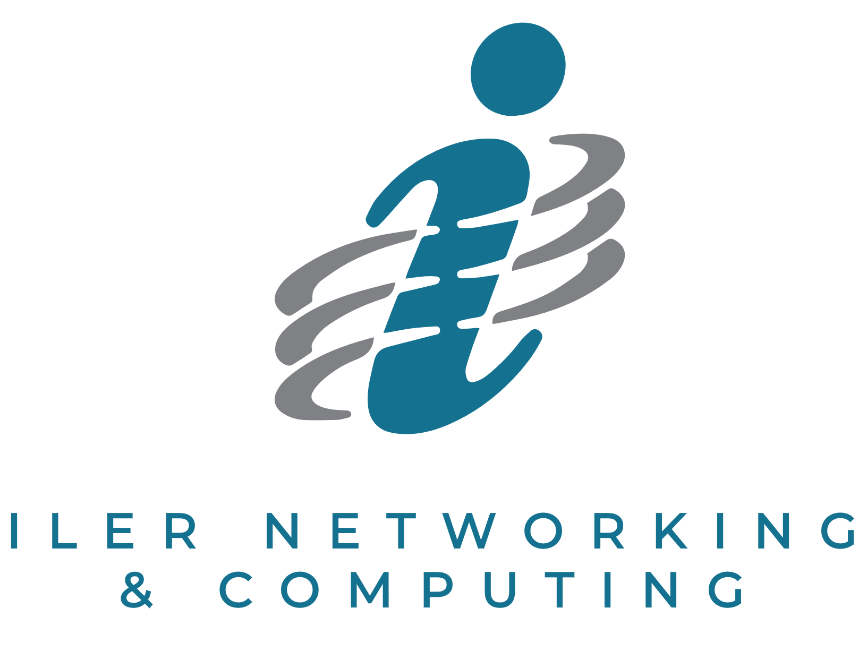
PRACTICAL AI PLAYBOOK
10 Easy Ways to Use AI
in Your Business This Month
A clear, actionable guide for turning artificial intelligence into everyday business value.

Created by Kent Iler
ILER Networking & Computing
PHONE  440-322-ILER (4537) | EMAIL  info@iler.com | WEB  www.iler.com

A BUSINESS-FIRST APPROACH TO AI

Introduction
The AI revolution isn't just for tech giants anymore. Small and medium-sized businesses can leverage powerful AI tools to save time, reduce costs, and deliver better customer experiences—starting today.
This guide offers 10 practical, accessible ways to implement AI in your business this month, with minimal technical expertise required. For implementations requiring more specialized knowledge, we've highlighted where a qualified IT provider like ILER Networking & Computing can help ensure your success.
Let's turn AI from a buzzword into a business advantage!

START THIS MONTH

10 Ways to Put AI to Work
1 | Automate Customer Service with AI Chatbots
What it does AI chatbots can handle frequently asked questions, provide product information, and even process simple transactions 24/7—without requiring staff.
How to start
- Identify your 10 most common customer questions
- Consider platforms like Tidio, ManyChat, or Intercom that offer ready-to-use AI chatbot templates
- Start with a simple implementation on your website or Facebook page
Expected impact Businesses typically see 25-40% reduction in routine customer service inquiries and significant improvement in response times.

2 | Generate Professional Marketing Content with AI Writing Tools
What it does AI writing assistants can draft emails, social media posts, product descriptions, and even blog articles that maintain your brand voice while saving hours of writing time.
How to start
- Sign up for a service like Jasper, Copy.ai, or WriteSonic
- Provide examples of your current marketing content to help the AI understand your style
- Begin with short-form content like social media posts before advancing to longer pieces
Expected impact Many businesses report producing 3-4x more content with the same staff resources, increasing their marketing reach without increasing workload.

3 | Streamline Document Processing with AI Data Extraction
What it does AI can automatically extract important information from invoices, receipts, contracts, and forms, eliminating manual data entry and reducing errors.
How to start
- Explore tools like ABBYY FineReader, Docsumo, or even the AI capabilities in Microsoft 365
- Start with a single document type (like invoices) to test accuracy
- Gradually expand to other document types as you build confidence
Expected impact Typical businesses reduce document processing time by 60-80% while significantly improving accuracy.

4 | Enhance Email Management with AI Assistance
What it does AI email tools can categorize messages, draft responses, summarize long email chains, and highlight action items—helping everyone in your organization manage their inbox more efficiently.
How to start
- Look into solutions like Superhuman, Front, or the AI features in Gmail or Outlook
- Focus first on email categorization and priority setting
- Gradually adopt AI-suggested replies as comfort levels increase
Expected impact Users commonly report saving 5-10 hours weekly on email management, allowing more focus on high-value work.

5 | Optimize Scheduling with AI Calendar Tools
What it does AI scheduling assistants can coordinate meetings between multiple parties, suggest optimal meeting times based on participants' availability and preferences, and even help balance your workday.
How to start
- Explore tools like Calendly, x.ai, or Clara
- Begin with external meeting scheduling to reduce back-and-forth emails
- Expand to internal meeting optimization as team adoption grows
Expected impact Businesses typically eliminate 80-90% of scheduling-related emails and reduce meeting scheduling time from days to minutes.

6 | Improve Customer Insights with AI Analytics
What it does AI can analyze customer data to identify buying patterns, predict future purchases, spot at-risk customers, and uncover cross-selling opportunities that humans might miss.
How to start
- Check if your existing CRM has AI capabilities (many now do)
- Focus first on one specific goal, like identifying customers likely to churn
- Use insights to create a targeted outreach campaign
Expected impact Businesses using AI for customer analysis typically see 15-30% improvement in customer retention and 10-25% increase in cross-selling success.

7 | Enhance Social Media with AI-Powered Tools
What it does AI tools can suggest optimal posting times, generate content ideas, identify trending topics in your industry, and even create basic graphics—all while measuring engagement.
How to start
- Consider platforms like Hootsuite, Buffer, or Sprout Social that now offer AI capabilities
- Start with content scheduling and optimal timing recommendations
- Experiment with AI-suggested content topics based on what's performing well
Expected impact Companies typically see 40-60% improvement in social media engagement with the same or less effort from their team.

8 | Streamline Recruitment with AI Screening Tools
What it does AI can screen resumes, identify qualified candidates, even conduct initial video interviews—dramatically reducing the time to find qualified candidates.
How to start
- Explore tools like Lever, HireVue, or the AI capabilities in platforms like LinkedIn
- Begin with resume screening for a single position type
- Establish clear criteria for what the AI should prioritize
Expected impact Hiring managers report 75% reduction in time spent on initial candidate screening and higher quality shortlists for interviews.

9 | Create Professional Visuals with AI Design Tools
What it does AI-powered design tools can generate logos, social media graphics, presentation slides, and more—without requiring professional design skills.
How to start
- Try user-friendly platforms like Canva, Adobe Express, or Midjourney
- Begin with simple social media graphics or presentation slides
- Use AI-generated designs as starting points that you can customize
Expected impact Companies typically reduce design costs by 30-50% while increasing the volume and consistency of visual content.

10 | Improve Decision-Making with AI-Powered Forecasting
What it does AI can analyze historical business data to predict future trends, from inventory needs to staffing requirements to cash flow projections.
How to start
- Check if your existing business software (ERP, accounting, inventory) offers AI forecasting features
- Start with a single, high-impact forecast (like inventory levels or sales projections)
- Compare AI predictions with actual results to build confidence in the system
Expected impact Businesses using AI forecasting typically reduce inventory costs by 10-25%, improve staff utilization by 15-30%, and make more confident strategic decisions.

A SIMPLE IMPLEMENTATION PATTERN

Getting Started: Your Next Steps
The most successful AI implementations follow this pattern:
1. Start small and focused – Choose one area where AI could make an immediate difference
2. Establish clear success metrics – Know how you'll measure improvement
3. Get team buy-in – Involve the people who will use the technology
4. Test and refine – AI improves with feedback and iteration
5. Scale what works – Once you've proven value, expand to related areas
KNOW WHEN EXPERT SUPPORT ADDS VALUE

When to Contact a Qualified IT Provider Like ILER Networking & Computing
While many AI tools are designed for business users, there are specific situations where working with a qualified IT provider like ILER Networking & Computing can save you time, money, and potential headaches:
1 | When Security and Compliance Matter  Consider professional help when:  - Your AI implementation will handle sensitive customer data  - You operate in a regulated industry (healthcare, financial services, legal)  - You need to ensure proper data access controls and permissions  - You're concerned about potential data breaches or privacy issues  Example A healthcare provider implementing AI for patient scheduling needs to ensure HIPAA compliance and proper data security protocols—areas where ILER Networking & Computing has specialized expertise.

2 | When Systems Need to Talk to Each Other  Consider professional help when:  - Your AI tool needs to connect with existing business systems  - You want to automate data flows between multiple applications  - You need custom integrations not covered by out-of-box solutions  - You want to avoid duplicate data entry across systems  Example A manufacturing company implementing AI for inventory forecasting needed their AI tool to pull data from their ERP system, supplier portal, and production software—a complex integration ILER Networking & Computing completed in just two weeks.

3 | When You Need Custom Solutions  Consider professional help when:  - Off-the-shelf AI tools don't quite fit your unique business needs  - You need AI trained on your specific business data  - You want to combine capabilities from multiple AI tools  - You need custom reporting or dashboards  Example A regional retail chain wanted AI-powered customer insights specific to their unique buying patterns and regional preferences. ILER Networking & Computing created a custom solution that delivered 34% more accurate recommendations than generic AI tools.

4 | When You Want to Scale Quickly  Consider professional help when:  - You're ready to move beyond initial experiments  - You want to roll out AI tools to multiple departments or locations  - You need to standardize AI implementation across your organization  - You want to accelerate your AI adoption timeline  Example After a successful AI chatbot pilot, a financial services firm wanted to expand across all customer service channels. ILER Networking & Computing created a comprehensive implementation plan that reduced the timeline from 9 months to just 6 weeks.

5 | When You Need Strategic Guidance  Consider professional help when:  - You're unsure which AI technologies make sense for your business  - You want to develop a roadmap for AI adoption  - You need help building internal capabilities and knowledge  - You want to maximize ROI on your AI investments  Example A professional services firm knew they wanted to implement AI but weren't sure where to start. ILER Networking & Computing conducted an AI readiness assessment that identified three high-impact, low-effort opportunities they hadn't considered.

PRACTICAL SUPPORT, BUILT AROUND BUSINESS OUTCOMES

How ILER Networking & Computing Can Help
At ILER Networking & Computing, we specialize in helping small and mid-sized businesses implement AI solutions that deliver real business value. Our approach focuses on practical applications that solve actual business problems—not hype or unnecessary complexity.
• AI readiness assessments | • System integration and data preparation
• Security and compliance reviews | • Custom AI solution development
• Staff training and change management | • Ongoing support and optimization

Ready to get started?  Contact us today for a free 30-minute AI readiness consultation.  Let us help you turn AI possibilities into business realities this month! | Phone  (877) 250-4537  Email  info@iler.com  Web  iler.com/ai-edge
© 2026 ILER Networking & Computing
Download additional resources at aiedgebook.com

